**ABSTRACT**

Online Mock System will provide a basis for effective fulfillment of conducting online tests as a replacement for the paper based tests which are conducted during the internals in the college. It is a generic software which is not specifically for our project but can also be used by any college, school or institute.

We will be developing this website because of the following reasons:

* Presently if the teachers conduct any objective test they have to check the answer sheets manually which is time consuming.
* Students cannot do practice of attempting objective questions papers.
* Generation of result manually might result in errors.

The Online Mock Test will be overcoming the above mentioned problems and will be providing the following

Features:

* There will be a real time testing environment.
* Test creation will become easier which will be including incorporation of new questions and deletion and modification of already existing questions periodically.
* Result and answer will be displayed instantaneously just after the completion of test.
* The records of the student will be updated in their profile after completion of their test for futures references.
* There will be different level of questions in the paper so that the judgement of student knowledge can be done efficiently.
* There will be zero paper work.

.

**EXISTING SYSTEM**

* TheExisting system of conducting examination process is manual. It has so many problems.
* So we introduce a new system, which is fully computerized.
* Existing system is a large man power process and is difficult to implement. Working of existing system is given below
* Student Registration is the first process .As the part of the registration, the student has to enter his name, address etc. into the registration form.
* After the registration, make the question papers and it will give to the prospective student.
* The question papers contain total mark, subject, duration, question paper etc.
* A group of person does evaluation of answer sheet. After the evaluation of the Answer sheet, the result is published. And also make the marks document.

**PURPOSE OF THE SYSTEM**

* The main purpose of the system is to efficiently evaluate the candidate thoroughly through a fully automated system that not only saves a lot of time but also gives fast results.
* It is a cost-effective and popular means of mass- evaluation system.
* The admin of the system prepares the tests and questions for each exam.
* The user can login through the user login with their register USERID and PASSWORD given to them and can take the exam.
* Ranking system is there so that the user can compete with other user.
* The result analysis is very easy as it is done by the system.
* So it saves a lot of time since no manual correction is needed in the system.
* No restriction is there that the invigilator has to be present when the students take the test.

**PROPOSED SYSTEM**

* The main objective of the online mock test is that it helps user to take exam 24/7 it also helps the user to understand his/hers growth.
* It reduces the time consumption and workload that exist in the current system of test.
* It also helps in storing the record of each test and the results are also stored in the system. This makes the searching of the records easier than the existing system.
* It creates a user-friendly environment, where a normal user can access through all the benefits of the system.
* It provides security from unauthorized access, only admin or authorized users are access granted to the system.
* Easy access of saved data inside the system (only for admins).

**SYSTEM REQUIREMENT**

**SOFTWARE REQUIREMENT**

* Operating System: Windows XP or greater
* Programming Language: PHP, MySQL
* Software Used: MS Word and Notepad++, Google Chrome or Firefox, Xampp

**HARDWARE REQUIREMENT**

* Pentium-IV (Processor)
* 256 MB Ram
* 512 KB Cache Memory
* Hard Disk 15GB

**FLOWCHARTS**

**Website Flowchart**

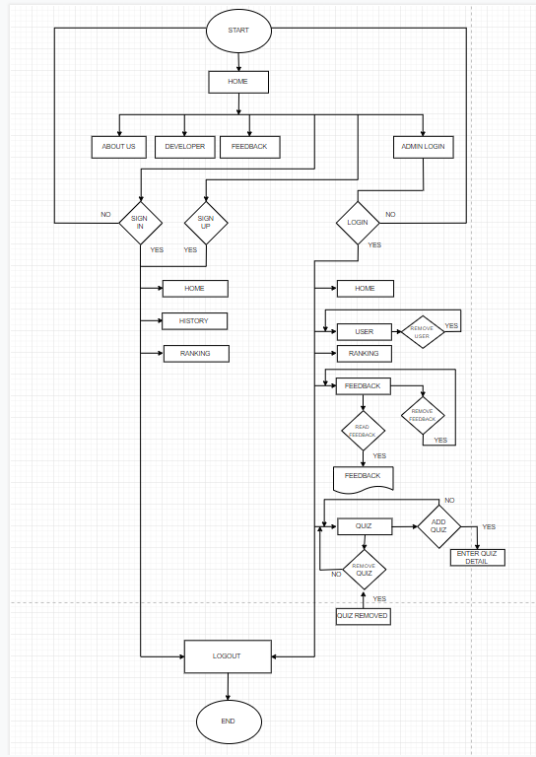

Figure : Flowchart of Website

**DATA FLOW DIAGRAM**

**0 Level DFD**

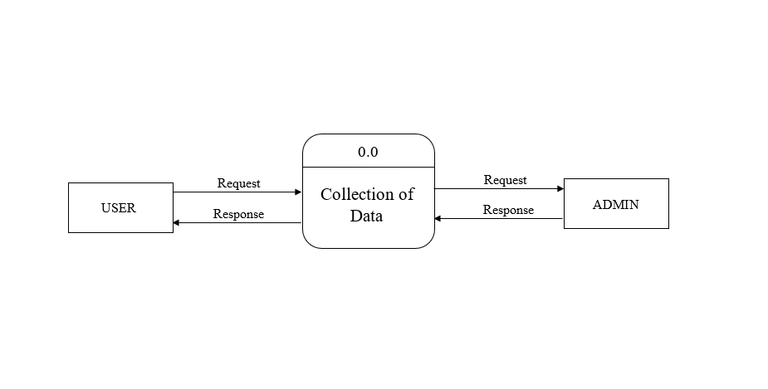

Figure :Data Flow Diagram

**1st Level DFD**

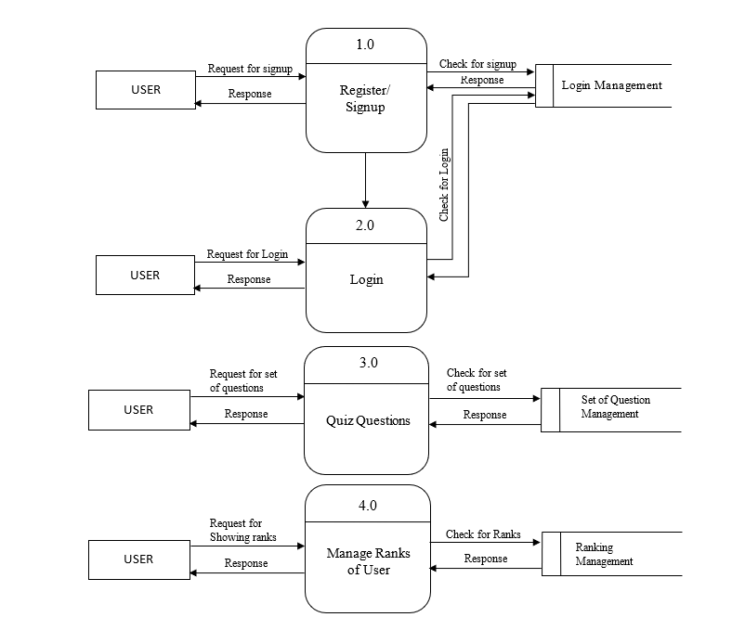

**FUTURE SCOPE**

Future scope are the perquisite for development of a system. Every existing system has proposed enhancements which make it better and easier to use and more secure. The enhancements that have been proposed for this system are listed here:

* More features can be added to the website like uploading college notes, syllabus, etc.
* Multiplayer quiz challenge can be added.
* Can use cookies for better data collection.
* Introduce mobile version of website i.e. Android Application.
* At present only one user’s website visited data can be tracked.

**REFERENCES**

**BIBLIOGRAPHY**

* 1.“Joy of PHP Programming”, “Alan Forbes”.
* 2.“PHP & MySQL Novice to Ninja”, “Kevin Yank”.

**WEBLIOGRAPHY**

* <https://www.tutorialspoint.com/php/>